**Docker Task -2**

**Task Description:**

Create a dockerfile, docker-compose file which when executed must display your basic details in the website.

**Project Structure**

Let's organize the files in a simple directory structure:

* my-info-website/
* Dockerfile
* docker-compose.yml
* html/ index.html

Step 1: Lauch the EC2 instance and install the necessary application.

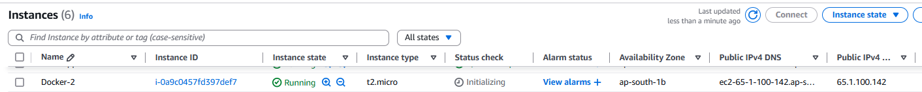

Step 2. To launch a basic detail in the website create a index.html

Now create a Dockerfile and docker-compose.yml

Step 3: Install the Docker

Step 4: Build and Run with docker image

Navigate to the my-info-website directory in your terminal and run:



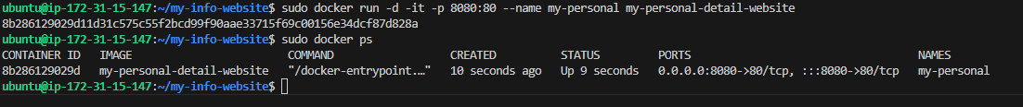

Now site will be reachable from publicip with the port 8080 .

